**Lab 10 Image Service and Online Raster Analysis**

**-Answers-**

**REMINDER: DO NOT CHANGE THE FORMAT OF THIS DOCUMENT. ALTER SPACING BETWEEN QUESTIONS AS NECESSARY.**

**/35**

**Name: Jacob Dietrich** **Date: 11/4/2021**

1. **Is this service based on a digital terrain model or a digital surface model?** (1)

This service is based on a digital terrain model.

1. **Is this image service good for direct visualization, analysis, or both?**(2)

This service is good for analysis, but not direct visualization. It provides data as floating point elevation values.

1. **How many server-side functions are provided by this layer?** (1)

There are 10 server- side functions provided by the layer. Slope Degrees, Slope Percentage, Aspect, Ellipsoidal Height, Hillshade, Multi-Directional Hillshade, Dark Multi-Directional Hillshade, Elevation Tinted Hillshade, Slope Map, Aspect Map.

1. **What is the spatial resolution (i.e., pixel size with the unit) of FEMA LiDAR DTM and SRTM 1 arc second dataset for U.S. area, respectively?** (2)

FEMA LiDAR DTM has a spatial resolution of 3 meters and SRTM 1 arc second has a pixel size of 31 meters.

1. **Is this terrain image layer published by a raster dataset or mosaic dataset?** (1)

This terrain image layer is published by a mosaic dataset.

1. **Make a screenshot of the pop-up showing the terrain information for the City of Fredericksburg, VA derived from *NED_1r9_arcsec*?** (2)

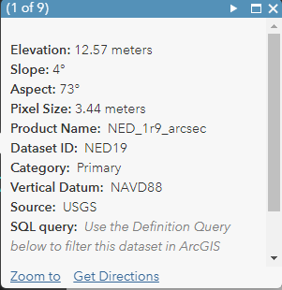

1. **Provide the URL of your app.***(13, see the rubric)*

https://umw.maps.arcgis.com/apps/ImageInterpretation/index.html?appid=896bd5098ece4dc897b1e8bd4105c2d8

1. **Make a screenshot of the ENTIRE INTERFACE of your web app (not just the map area) showing****the*****FEMA_LIDAR_DTM* image.** (1)

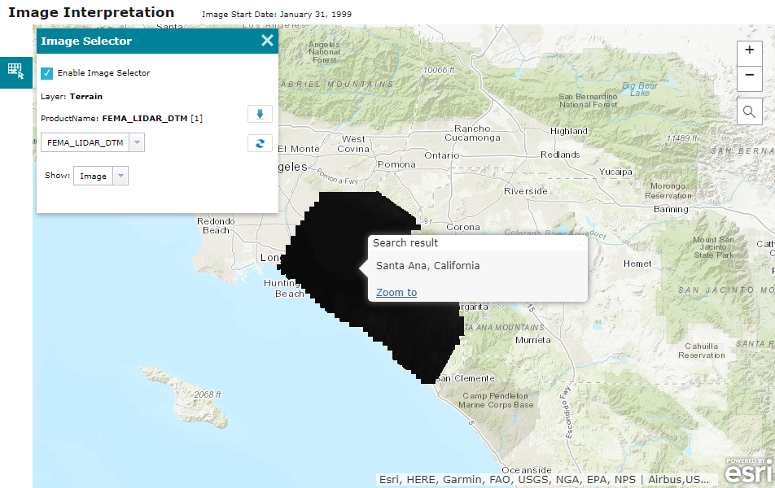

1. **Make a screenshot of the ENTIRE INTERFACE of your web app (not just the map area) showing the *Aspect_Map* image.** (1)

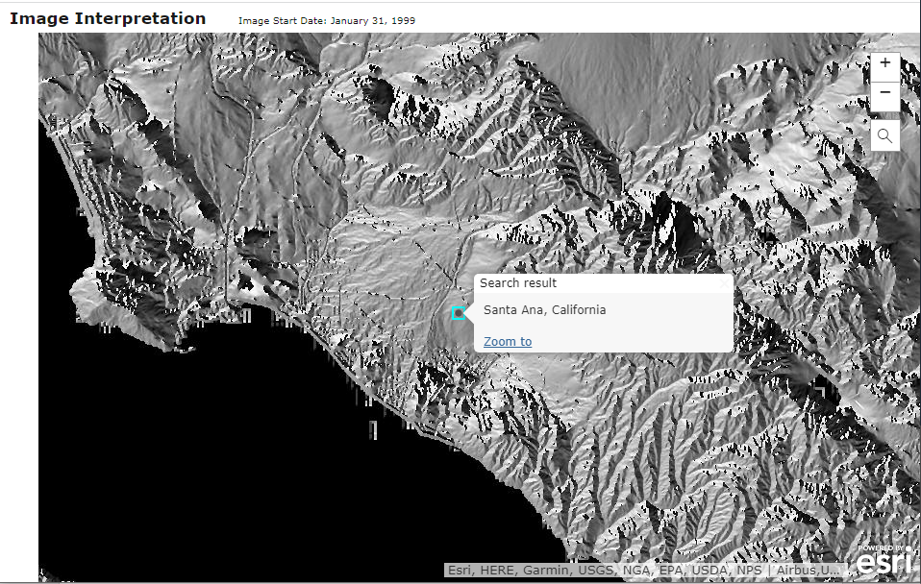

1. **Make a screenshot of the ENTIRE INTERFACE of your web app (not just the map area) showing the *Compare* tool info window and the vertical slider in the middle of the FEMA_LIDAR_DTM image.** (1)

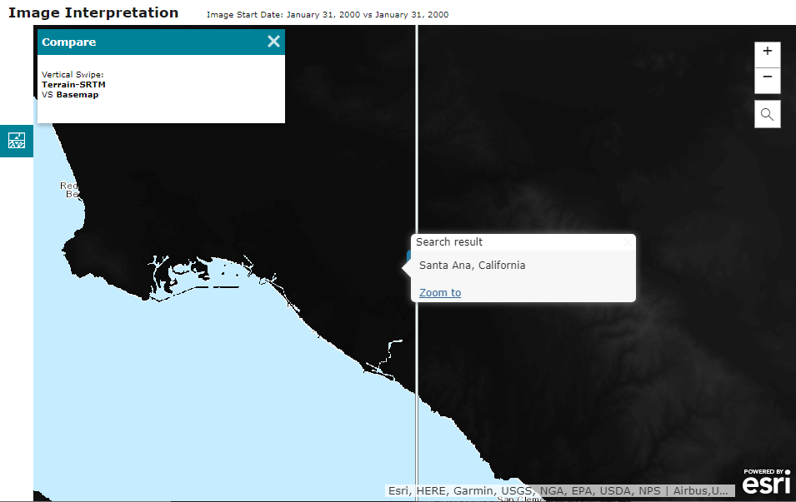

1. **Make a screenshot of the ENTIRE INTERFACE of your web app (not just the map area) showing your change detection result.** (1)

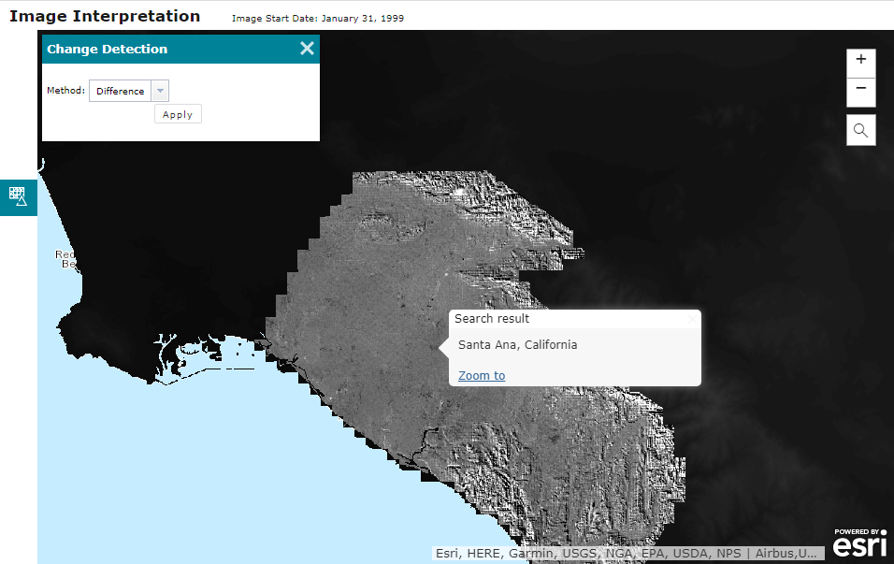

1. **Create a screenshot of the *Catalog pane in ArcGIS Pro* showing the image service you published on the ArcGIS Server.** (2)

1. **Create a screenshot showing the FULL Extent of each display:** ***Aspect*, *Slope*, *Hillshade*.**(3)

1. **Make a screenshot of the ENTIRE INTERFACE of your web app showing your elevation layer and profile graph.** (3)
2. **Make a screenshot of your EC2 Instance page showing your instance is stopped.** (1)

